**Climate moderates composition of plant-pollinator networks**

Manu E. Saunders1,2, Liam K. Kendall1,3, Jose B. Lanuza1, Mark A. Hall4, Romina Rader1, Jamie Stavert1

1Ecosystem Management, School of Environmental and Rural Science, University of New England, Armidale NSW 2351 Australia

2UNE Business School, University of New England, Armidale NSW 2351 Australia

3CSIRO Agriculture, GPO Box 2583, Brisbane QLD 4001, Australia

4Hawkesbury Institute for the Environment, Western Sydney University, Richmond NSW 2753 Australia

**Introductory paragraph (abstract)**

Climate can have a strong influence on pollinator communities because insects have limited ability to regulate body temperature and are thus more sensitive to climatic extremes. Yet we know little about how climate drives pollinator community composition at the global scale. Here we analyse 184 plant-pollinator networks from the five major Köppen climate zones to show that climate moderates the relative proportion of flower-visiting insect taxa in pollinator communities. Relative to other taxa, non-syrphid Diptera had the greatest proportion of links in polar zone networks, while bees dominated temperate zone networks. Bee species were the most generalised pollinators (i.e. visited the most number of plants in a network), especially in the tropical zone. Our results contribute substantial advances in knowledge of how climate influences pollinator community composition at the global scale and identify the need for greater research effort to understand the effects of global environmental change on plant-pollinator interactions.

**Main**

Animal pollinators are critical to maintaining ecological function in most terrestrial ecosystems, and insect taxa, particularly Lepidoptera, Hymenoptera, Coleoptera and Diptera, are the most diverse and abundant groups of known pollinators1. Identifying how environmental conditions influence plant-pollinator interactions is critical to understand how pollinator communities and pollination services may vary in response to environmental change. Insects are ectothermic and their behaviour and physiology respond quickly to changing environmental conditions, including seasonality, weather conditions and resource availablity2. Rainfall patterns can influence plant-pollinator interactions by altering phenological phases or floral resource quality, or affecting pollinator foraging patterns and sensory signals3. Temperature also has a strong influence on plant-pollinator interactions. The activity of flower visiting insects generally increases as ambient temperature rises, and warmer flowers may attract more pollinators4,5. Thermal tolerance varies across taxonomic groups, meaning that climatic conditions are likely to influence the composition of insect pollinator communities across space and time. For example, dipterans are generally thought to be more cold-tolerant than other flying insects and have been recorded as the most common flower visitors in some arctic and alpine plant-pollinator networks6,7, as well as at sites with cooler temperatures in other climate zones8. Bees are most abundant and diverse in warm arid regions9, and are generally less active during winter and in cold, inclement weather. This diversity of environmental responses among taxa provides buffering effects for ecosystem function and delivery of ecosystem services10,11. Understanding how these local and regional patterns translate to larger scales can help understand how plant-pollinator interaction networks may be influenced by global environmental change.

Historically, plant-pollinator network studies have been localised, descriptive and focused on documenting diversity and interactions12; hence broader understanding of geographical trends is limited13. In particular, there is currently no consensus on how climate drives plant-pollinator network interactions across large spatial scales14. The small number of studies that have identified effects of climate on plant-pollinator networks have been largely speculative, based on simulated data, or from local or regional systems15,16. Large-scale analyses investigating global patterns in plant-pollinator networks have focused on broader patterns in network metrics and species richness, with limited discussion of taxonomic identity or community composition17–19. Where biogeographical gradients were considered, the focus has traditionally been on testing the effects of latitude on network interactions20,21. However, latitude is a poor proxy for the environmental nuances that drive community-level interactions, and historical focus on the latitudinal gradient as a predictor has limited our understanding of global-scale patterns of ecosystem function22. To test whether climate zone influences the relative proportion of insect taxa in plant-pollinator networks, we conducted an exhaustive search of peer-reviewed literature and research theses published online and collated 184 community networks linking flowering plants to insect pollinators or flower visitors. Hereafter, we refer to these as plant-pollinator networks.

**Results**

We first tested variation in the composition of plant-pollinator communities, which is more useful for understanding community-level patterns than species abundance or richness metrics. At the global scale, we found that Köppen climate zone drives compositional dissimilarities between plant-pollinator interactions (PERMANOVA, F(4,179) = 63.23; *R2* = 0.59; *P* < 0.001; Figure 1). In particular, the composition of tropical and arid zone networks are distinct from each other and from all other climate zones (Table S1). The composition of temperate zone plant-pollinator networks is strongly dissimilar from polar zone networks, while networks in the continental climate zone are weakly dissimilar from those in temperate and polar climate zones. Dispersion of plant-pollinator interaction composition is similar across all climate zones (all pairwise Tukey’s HSD *P* > 0.05).

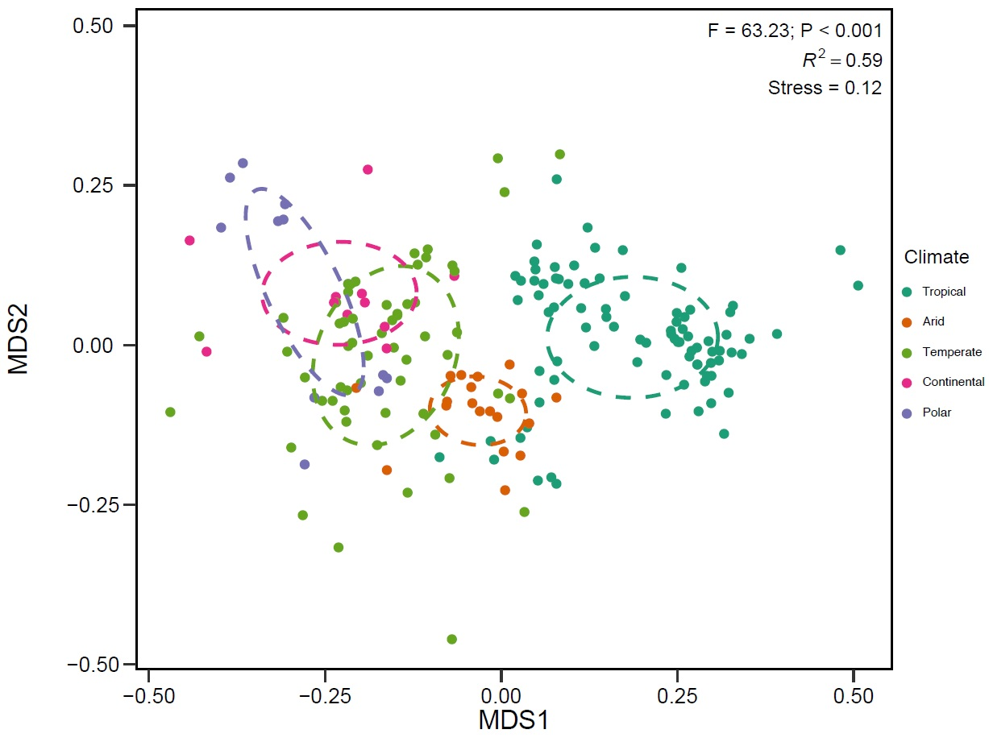

**Figure 1.** NMDS ordination of plant-pollinator interaction composition in each climate zone.

To explore relative differences in pollinator taxa across climate zones, we used Bayesian generalised linear mixed effects models and grouped pollinator species by the following taxonomic groupings: Syrphidae, non-syrphid Diptera, Bees, non-bee Hymenoptera, Lepidoptera, Coleoptera. Analysis at family-level was not feasible, due to a high number of singletons, but we separated syrphid flies and bees from their respective taxonomic orders, as adults of these species are predominantly pollen-feeders and are common and recognisable pollinators across most terrestrial systems1,23. We focused on two complementary models: (i) at the group level, we calculated the proportion of links in each network, within each climate zone, held by all species in the respective taxonomic group; (ii) within each taxonomic group, we estimated species-level absolute generalism, i.e. number of plant partners (degree) within a given network, in a given climate zone, that were visited by a species in that group. Taxa comprising a higher proportion of network links may be more suited to the relevant environmental conditions24. However, a taxonomic group can dominate a network, but that group may be comprised predominantly of specialist species.

We found that, relative to other taxonomic groups, bees had the greatest proportion of links in continental (~32%) and temperate (~30%) climate zones (Figure 2A). Tropical zone networks were dominated by bees (~26%) and non-syrphid Diptera (~24%), while polar zone networks were dominated by non-syrphid Diptera (~36%) (Figure 2A). Arid and continental zone networks showed the greatest overlap among taxonomic groups, with Hymenoptera and Diptera groups holding the highest proportion of links in these zones. At the species level, there was high variation among taxa and climate zones, but most taxonomic groups showed high specialisation, particularly in temperate and continental networks (Figure 2B). Bee species, on average, were the most generalised (i.e. visited the most number of plant partners) in nearly all climate zones (Figure 3), except polar where Syrphidae were the most generalised (average 2.5 plant partners per syrphid species) (Figure 2B). Overall, the highest level of absolute generalism was found for bee species in tropical networks (average 3 plant partners per bee species) (Figure 2B).

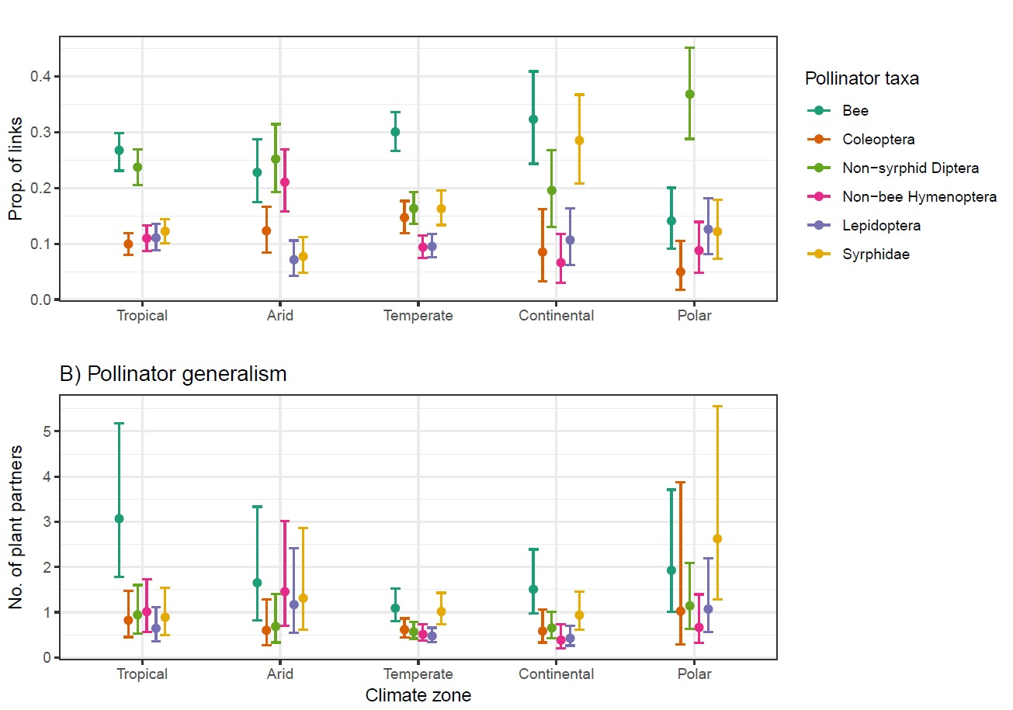

**Figure 2.** (A) Model-estimated proportion of network links at the taxonomic group level and (B) species-level absolute generalism for each pollinator taxonomic group, in each climate zone. Dots are posterior mean estimates and error bars denote ± 95% credible intervals. Predictions of pollinator generalism are constrained to equal network size (100 plant-pollinator links).

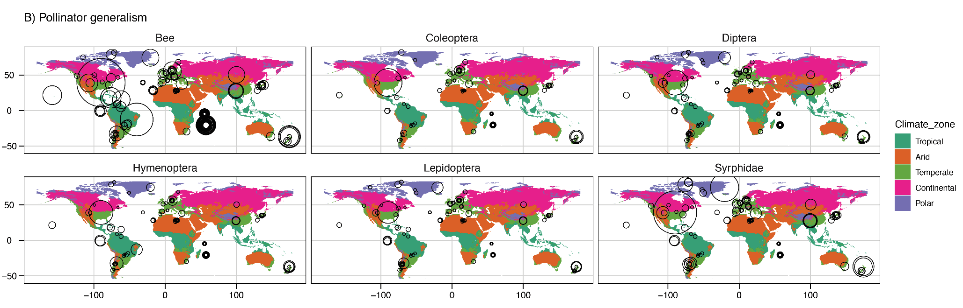

**Figure 3** Global map of absolute generalism for each pollinator taxonomic group within climate zones. Circles represent individual networks. Circle size is relative to the model estimates for pollinator generalism (number of plant partners) for each pollinator taxonomic group within each network. Predictions of pollinator generalism are constrained to equal network size (100 plant-pollinator links).

Relative to other taxa, bees and flies had the greatest proportion of links in all networks across all climate zones, while lepidopterans, coleopterans and non-bee hymenopterans had less than 15% of links in nearly all networks and were consistently more specialised than other pollinator species. The only exception was non-bee hymenopterans in arid zone networks, where these species had a higher number of links and visited more plant partners compared to other climate zones. Bees are generally considered the most important pollinators globally, but knowledge of other pollinators is limited1,25, therefore our results should stimulate greater research effort into understanding the relative importance of non-bee pollinator taxa in different systems, as well as variation in pollinator community effectiveness across space and time26.

We provide empirical evidence at the global scale to support individual reports6,27 that flies are the most commonly-observed pollinator (relative to other taxa) in polar zone plant-pollinator networks. We also highlight how focusing on specific pollinator taxa in plant-pollinator community studies can overlook important information about community-level interactions. For example, non-syrphid Diptera have the greatest proportion of network links (about 35%) in polar zone networks, but most non-syrphid Diptera species are actually quite specialised, having on average approximately one plant partner in each network. In contrast, Syrphidae had a much lower proportion of links in polar networks (approximately 12%), but were more generalised relative to other species, showing the highest number of plant partners and the greatest variation in generalism among species. Similarly, bee species visited the highest number of plant species in tropical zone networks; but bees, as a taxonomic group, had the greatest proportion of network links in continental and temperate zones. Plant richness *per se* is unlikely to be driving the differences in pollinator generalism we find here, because climate zone strongly predicted composition of plant-pollinator communities (Figure 1), despite there being no difference in network-level plant richness between climate zones (*Supp Material).

Our analysis is based on the most comprehensive set of insect pollinator networks collated thus far. Moreover, we separate insect pollinators into taxonomic groups for analysis, whereas other studies have largely considered overall patterns for all pollinators, often grouping vertebrates and insects together. In addition, we focus on relative proportions of observed pollinator taxa, rather than comparing network structure or diversity metrics, which can be influenced by sampling effort or network size. We also found that climate is a more powerful predictor of insect community composition in plant-pollinator networks than latitude (*Supp material), despite latitude receiving much attention as a potential driver of plant-pollinator interactions20,22. Furthermore, although previous work has discussed the influence of climate on plant-pollinator networks20, relationships have mostly been tested using temporal or annual temperature data. Yet climate is a multivariate space encompassing more than temperature fluctuations. Köppen climate zone classifications are extremely useful for aggregating complex climate gradients and vegetation patterns into simple, ecologically meaningful categories28. We now require additional networks across underrepresented regions of the world to test whether the sub-categories of the Köppen classifications can better predict more complex environmental variation in plant-pollinator community interactions.

Climate change affects plant-pollinator networks through phenological mismatches, with potentially devastating effects on ecosystem function16. Interaction networks can be more useful for understanding these effects than simple diversity metrics, because interactions are based on complex patterns of co-occurrence, phenology, behaviour, and physiology; hence, even minor changes to individual interactions can have significant effects on community structure and ecological processes29. We have contributed new information on how composition of plant-pollinator networks varies across climate zones, which is a key first step to developing detailed analyses that identify how climate change affects species- and community-level interactions at local and regional scales.

**Methods**

We collated 184 plant-pollinator networks that met our criteria from multiple sources: the Web of Life ecological networks database (<http://www.web-of-life.es/>); an exhaustive search of published journal articles, data repositories, and theses; and by directly contacting researchers of plant-pollinator network studies. Although it is likely we have missed some networks, we are confident our analysis is more comprehensive than previous global network analyses, because we cover all climate zones and sourced additional networks that have not been included in previous studies. We only used insect pollinator networks that recorded multiple taxonomic orders and thus did not focus on a single order or taxonomic group. We used the *taxize* package30 (v.0.9.5) to identify both plant and insect families and orders from the datasets.. All networks were analysed as binary networks, to address differences in sampling methods and effort among networks. We identified the Köppen climate zone for each network based on the spatial coordinates provided with each dataset using the *kgc* package (v1.0.0.2)31. All code and analyses are available at <https://github.com/JoseBSL/Geonet>.

We tested whether the composition of plant-pollinator interactions varied among climate zones by calculating pairwise Raup-Crick dissimilarity32 between networks using the *vegan* package (v.2.5-3)33. To account for varying network sizes, we computed the Raup-Crick dissimilarity using a null model, repeated for 999 iterations, to account for differing species’ richness in each network. Then, we assessed differences in the composition of plant-pollinator interactions among climate zones using a permutational analysis of variance (PERMANOVA)34. We evaluated dispersion of network dissimilarity values among climate zones with a permutational test of multivariate homogeneity of group dispersion (PERMDISP) and post-hoc pairwise Tukey’s Honest-Significant Difference (HSD) tests. We computed pairwise differences in the composition of plant-pollinator interactions between each climate zone using a pairwise PERMANOVA35. To account for multiple comparisons, *P*-values were adjusted using the false discovery rate (FDR) method36. Finally, we visualised differences in plant-pollinator interactions among networks in two-dimensional space with non-metric multidimensional scaling (NMDS) ordination.

To test whether climate zone influenced how pollinator taxa interacted with plants within each network, we focused on the following taxonomic groupings: bees, non-bee Hymenoptera, Coleoptera, Lepidoptera, non-Syrphid Diptera, and Syrphidae. We separated bees from non-bee Hymenoptera, and syrphid flies (Syrphidae) from non-syrphid Diptera, because bees and syrphid flies are the most globally-recognised pollinator taxa from their respective orders. We focus on two interaction measures: (i) proportion of links, the proportion of total links in each network for each pollinator taxonomic group, which we calculated as the sum of unique links within each pollinator group, divided by the total sum of unique links within each network; (ii) absolute species generalism, which is the total number of links between each pollinator species to different plant species within a network. To estimate the proportion of links and absolute species generalism for each pollinator group within each climate zone, we specified Bayesian generalised linear mixed effects models using the *brms* package (version 2.5.0)37. These models were fit with beta and negative binomial distributions respectively. In each model, the response variable was the proportion of links for each pollinator taxonomic group or the number of species links within each network. Fixed effects were “pollinator taxa” (categorical), “climate zone” (categorical) and the two-way “pollinator taxa”:“climate zone” interaction. To account for differences in network size in the species absolute generalism model, we included an offset term of the log-transformed total number of plant-pollinator links within each network. In both models, we included a random effect of “network” nested within “study” to account for the dependent data structure of multiple networks within studies. We re-iterated each model with absolute latitude in interaction with pollinator taxa instead of climate zone and compare their predictive power using the widely applicable information criterion (WAIC). The interaction between ‘pollinator taxa : climate zone’ was the best predictor for pollinator generalism (Bayesian *R2*: 0.265).

Pairwise differences between climates and pollinator group for either proportion of network links or pollinator species generalism were considered significant when the 95% highest density intervals did not overlap zero (see Supplementary Information, Table SX)38. We set weakly informative priors and manipulated Δ and maximum tree depth to reduce divergent transitions. We undertook posterior predictive checks visually using *bayesplot* (v1.6.0)39 and *Shinystan* (v.2.5.0)40. All data analyses were undertaken in R (v.3.5.1, R Core Team 2018).

**Author Contributions**

MES conceived the idea and led the study; LKK and JS wrote the code and conducted data analysis; all authors collated datasets, contributed to study design and manuscript preparation.

**Acknowledgements**

Thank you to all authors who published network matrices openly online, or sent us matrices upon our request. MES and JS are supported by individual UNE Postdoctoral Fellowships; RR is supported by ARC DExxxxx???; LKK is supported by an Ian Potter Foundation PhD scholarship grant and a CSIRO PhD top-up scholarship.

**Data availability**

All data, code and analyses are available at <https://github.com/JoseBSL/Geonet>.

1. Ollerton, J. Pollinator diversity: distribution, ecological function, and conservation. *Annu. Rev. Ecol. Evol. Syst.* **48**, 353–376 (2017).

2. Tauber, M. J. & Tauber, C. A. Insect Seasonality: Diapause Maintenance, Termination, and Postdiapause Development. *Annu. Rev. Entomol.* **21**, 81–107 (1976).

3. Lawson, D. A. & Rands, S. A. The effects of rainfall on plant–pollinator interactions. *Arthropod-Plant Interact.* (2019). doi:10.1007/s11829-019-09686-z

4. Rands, S. A. & Whitney, H. M. Floral Temperature and Optimal Foraging: Is Heat a Feasible Floral Reward for Pollinators? *PLOS ONE* **3**, e2007 (2008).

5. Sapir, Y., Shmida, A. & Ne’eman, G. Morning floral heat as a reward to the pollinators of the Oncocyclus irises. *Oecologia* **147**, 53–59 (2006).

6. Tiusanen, M., Hebert, P. D. N., Schmidt, N. M. & Roslin, T. One fly to rule them all-muscid flies are the key pollinators in the Arctic. *Proc. Biol. Sci.* **283**, (2016).

7. Elberling, H. & Olesen, J. M. The structure of a high latitude plant-flower visitor system: the dominance of flies. *Ecography* **22**, 314–323 (1999).

8. González, A. M. M. *et al.* Effects of climate on pollination networks in the West Indies. *J. Trop. Ecol.* **25**, 493–506 (2009).

9. Michener, C. D. Biogeography of the Bees. *Ann. Mo. Bot. Gard.* **66**, 277–347 (1979).

10. Rader, R., Reilly, J., Bartomeus, I. & Winfree, R. Native bees buffer the negative impact of climate warming on honey bee pollination of watermelon crops. *Glob. Change Biol.* **19**, 3103–3110 (2013).

11. Bartomeus, I. *et al.* Biodiversity ensures plant-pollinator phenological synchrony against climate change. *Ecol. Lett.* **16**, 1331–1338 (2013).

12. Knight, T. M. *et al.* Reflections on, and visions for, the changing field of pollination ecology. *Ecol. Lett.* **21**, 1282–1295 (2018).

13. Mayer, C. *et al.* Pollination ecology in the 21st Century: Key questions for future research. *J. Pollinat. Ecol.* **3**, 8–23 (2011).

14. Petanidou, T. *et al.* Climate drives plant-pollinator interactions even along small-scale climate gradients: the case of the Aegean. *Plant Biol.* **20 Suppl 1**, 176–183 (2018).

15. Memmott, J., Craze, P. G., Waser, N. M. & Price, M. V. Global warming and the disruption of plant-pollinator interactions. *Ecol. Lett.* **10**, 710–717 (2007).

16. Hegland, S. J., Nielsen, A., Lázaro, A., Bjerknes, A.-L. & Totland, Ø. How does climate warming affect plant-pollinator interactions? *Ecol. Lett.* **12**, 184–195 (2009).

17. Traveset, A. *et al.* Global patterns of mainland and insular pollination networks. *Glob. Ecol. Biogeogr.* **25**, 880–890 (2016).

18. Olesen, J. M. & Jordano, P. GEOGRAPHIC PATTERNS IN PLANT–POLLINATOR MUTUALISTIC NETWORKS. *Ecology* (2002).

19. Trøjelsgaard, K. & Olesen, J. M. Macroecology of pollination networks. *Glob. Ecol. Biogeogr.* **22**, 149–162 (2013).

20. Schleuning, M. *et al.* Specialization of mutualistic interaction networks decreases toward tropical latitudes. *Curr. Biol.* **22**, 1925–1931 (2012).

21. Ollerton, J. & Cranmer, L. Latitudinal trends in plant-pollinator interactions: are tropical plants more specialised? *Oikos* **98**, 340–350 (2002).

22. Moles, A. T. & Ollerton, J. Is the notion that species interactions are stronger and more specialized in the tropics a zombie idea? *Biotropica* **48**, 141–145 (2016).

23. Ssymank, A., Kearns, C. A., Pape, T. & Thompson, F. C. Pollinating Flies (Diptera): A major contribution to plant diversity and agricultural production. *Biodiversity* **9**, 86–89 (2008).

24. Tylianakis, J. M. & Morris, R. J. Ecological networks across environmental gradients. *Annu. Rev. Ecol. Evol. Syst.* **48**, 25–48 (2017).

25. Wardhaugh, C. W. How many species of arthropods visit flowers? *Arthropod-Plant Interact.* **9**, 547–565 (2015).

26. Willcox, B. K., Aizen, M. A., Cunningham, S. A., Mayfield, M. M. & Rader, R. Deconstructing pollinator community effectiveness. *Curr. Opin. Insect Sci.* **21**, 98–104 (2017).

27. Cirtwill, A. R., Roslin, T., Rasmussen, C., Olesen, J. M. & Stouffer, D. B. Between-year changes in community composition shape species’ roles in an Arctic plant–pollinator network. *Oikos* **127**, 1163–1176 (2018).

28. Beck, H. E. *et al.* Present and future Köppen-Geiger climate classification maps at 1-km resolution. *Sci. Data* **5**, 180214 (2018).

29. Tylianakis, J. M., Didham, R. K., Bascompte, J. & Wardle, D. A. Global change and species interactions in terrestrial ecosystems. *Ecol. Lett.* **11**, 1351–1363 (2008).

30. Chamberlain, S. A. & Szöcs, E. taxize: taxonomic search and retrieval in R. *F1000Research* **2**, 191 (2013).

31. Bryant, C., Wheeler, N. R., Rubel, F. & French, R. H. *kgc: Koeppen-Geiger Climatic Zones*. (2017).

32. Anderson, M. J. *et al.* Navigating the multiple meanings of β diversity: a roadmap for the practicing ecologist. *Ecol. Lett.* **14**, 19–28 (2011).

33. Oksanen, J. Multivariate Analysis of Ecological Communities in R: vegan tutorial. 43

34. Anderson, M. J. A new method for non-parametric multivariate analysis of variance. *Austral Ecol.* **26**, 32–46 (2001).

35. pairwise_adonis: Pairwise multilevel comparison using adonis in gauravsk/ranacapa: Utility Functions and ‘shiny’ App for Simple Environmental DNA Visualizations and Analyses. Available at: https://rdrr.io/github/gauravsk/ranacapa/man/pairwise_adonis.html. (Accessed: 25th January 2019)

36. Benjamini, Y. & Hochberg, Y. Controlling the False Discovery Rate: A Practical and Powerful Approach to Multiple Testing. *J. R. Stat. Soc. Ser. B Methodol.* **57**, 289–300 (1995).

37. Bürkner, P.-C. **brms** : An *R* Package for Bayesian Multilevel Models Using *Stan*. *J. Stat. Softw.* **80**, (2017).

38. Kruschke, J. *Doing Bayesian Data Analysis: A Tutorial with R, JAGS, and Stan*. (Academic Press, 2014).

39. Gabry, J. & Mahr, T. bayesplot: Plotting for Bayesian models. *R Package Version* **1**, (2017).

40. Gabry, J. *shinystan: Interactive visual and numerical diagnostics and posterior analysis for bayesian models [Computer software manual]*. (2016).